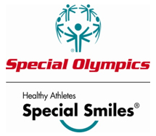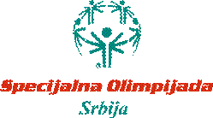

On 16th of April 2011 in city of Cacak a first Special Olympics Serbia Healthy Athletes event was held.
Dr Lidija Bondarenko held a first screening of Special Smiles,together with 2 other MD and 15 clinical volunteers.
During a National Special Olympics Serbia athletics tournament 121 athletes went through our clinic, having there teeth checked,learned how to care for there teeth properly and learning about dental hygiene in general.
This event had a great support from municipality of city of Cacak-they donated food for all of the participants at this event, and from Coca Cola who donated beverages.
Each of the participants went away with a gift toot paste (donated by Colgate) and a new,furthered knowledge of why it is so important to take good and regular care of their teeth.
The following Special Olympics Serbia sports clubs took part in this event: SK ,,Morava“-Čačak,SK ,,Mladost“-Pirot,SK ,,Arena“-Leskovac,SK ,,Kliker“-Pančevo,SK ,,Palestra“-Krusevac,SK ,,Sportsko Srce“-Jabuka,SK ,,Pčelice“-Kragujevac,SK ,,Šampion“-Niš,SK ,,Bubamare“-Leskovac,SK ,,Singidunum“-Beograd,SK ,,Hendi Sport“-Zrenjanin

